CONSULTAS SQL- SICHF

# INNER JOIN

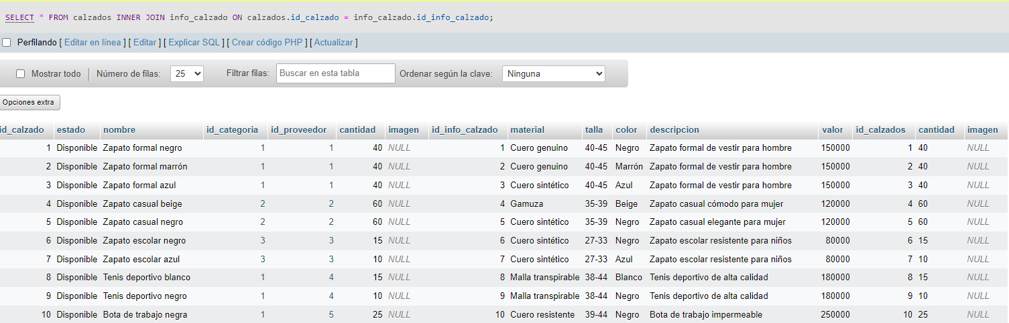

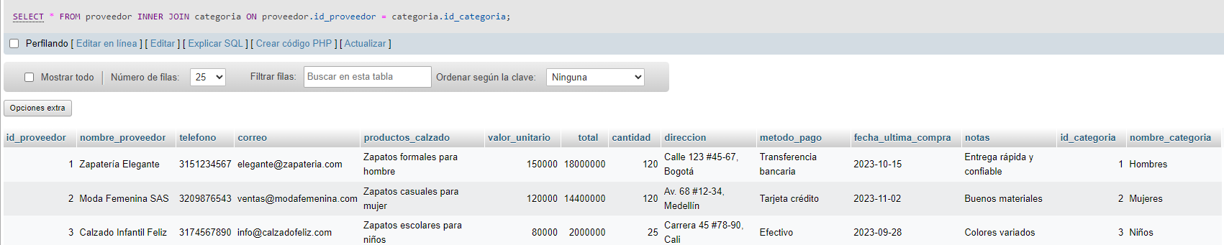

# INSERCIÓNES

INSERT INTO factura (id_usu, fecha_factura, valor_unitario, iva, total, descripcion_producto, cantidad_productos, Estado)

VALUES

(2,000, 100000, 10, 120000, 'Calzado de hombre material caucho', 1, 'Disponible'),

[INSERT](http://localhost/phpmyadmin/url.php?url=https://dev.mysql.com/doc/refman/8.0/en/insert.html) INTO pagos (metodo_pago, total, fecha_pago) [VALUES](http://localhost/phpmyadmin/url.php?url=https://dev.mysql.com/doc/refman/8.0/en/miscellaneous-functions.html%23function_values) ('PayPal', 300000, 14-05-25);

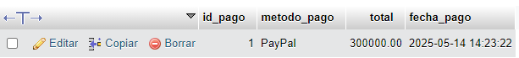

[INSERT](http://localhost/phpmyadmin/url.php?url=https://dev.mysql.com/doc/refman/8.0/en/insert.html) INTO pagos (metodo_pago, total, fecha_pago) [VALUES](http://localhost/phpmyadmin/url.php?url=https://dev.mysql.com/doc/refman/8.0/en/miscellaneous-functions.html%23function_values) ('PayPal', 800000, 10-05-23 );



# CONSULTAS

[SELECT](http://localhost/phpmyadmin/url.php?url=https://dev.mysql.com/doc/refman/8.0/en/select.html) nombre_proveedor FROM proveedor;

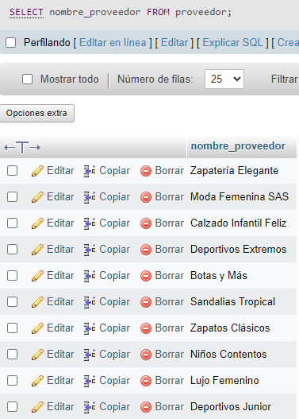

[SELECT](http://localhost/phpmyadmin/url.php?url=https://dev.mysql.com/doc/refman/8.0/en/select.html) * FROM info_calzado ORDER BY 1 ASC;

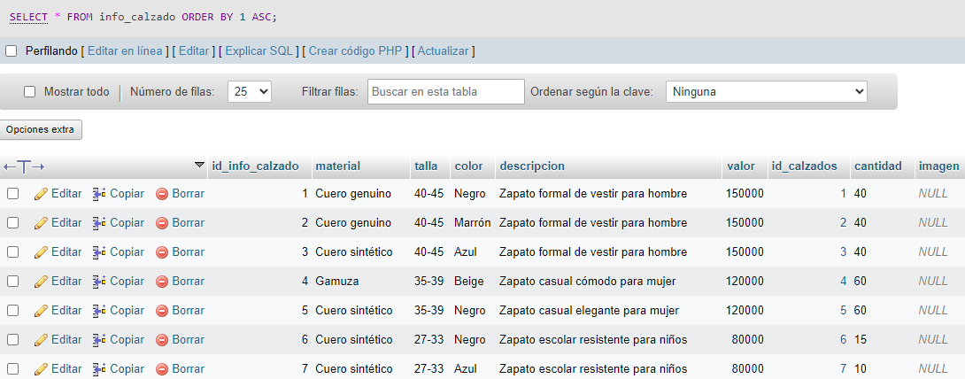

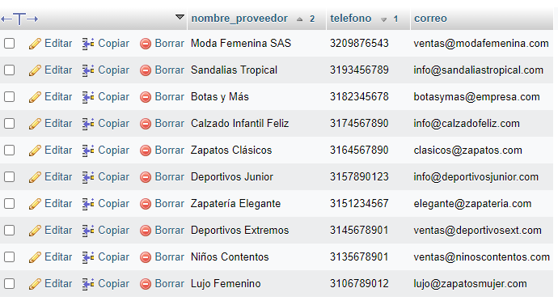[SELECT](http://localhost/phpmyadmin/url.php?url=https://dev.mysql.com/doc/refman/8.0/en/select.html) nombre_proveedor, telefono, correo FROM proveedor ORDER BY telefono DESC, nombre_proveedor ASC;

# SUBCONSULTAS

[SELECT](http://localhost/phpmyadmin/url.php?url=https://dev.mysql.com/doc/refman/8.0/en/select.html) * FROM proveedor WHERE total > ([SELECT](http://localhost/phpmyadmin/url.php?url=https://dev.mysql.com/doc/refman/8.0/en/select.html) [AVG](http://localhost/phpmyadmin/url.php?url=https://dev.mysql.com/doc/refman/8.0/en/aggregate-functions.html%23function_avg)(total) FROM proveedor);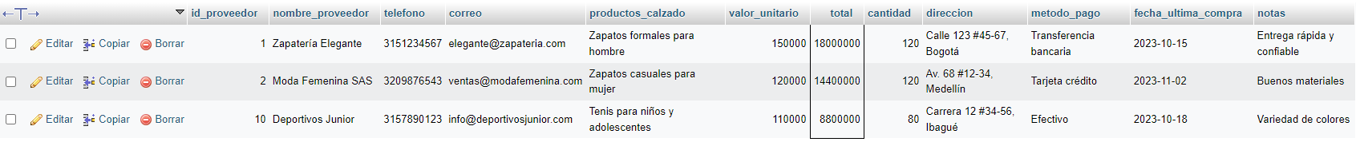

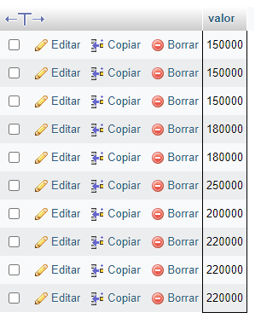[SELECT](http://localhost/phpmyadmin/url.php?url=https://dev.mysql.com/doc/refman/8.0/en/select.html) valor FROM info_calzado WHERE valor > ([SELECT](http://localhost/phpmyadmin/url.php?url=https://dev.mysql.com/doc/refman/8.0/en/select.html) [AVG](http://localhost/phpmyadmin/url.php?url=https://dev.mysql.com/doc/refman/8.0/en/aggregate-functions.html%23function_avg)(valor) FROM info_calzado);

[SELECT](http://localhost/phpmyadmin/url.php?url=https://dev.mysql.com/doc/refman/8.0/en/select.html) cantidad FROM calzados WHERE cantidad > ([SELECT](http://localhost/phpmyadmin/url.php?url=https://dev.mysql.com/doc/refman/8.0/en/select.html) [AVG](http://localhost/phpmyadmin/url.php?url=https://dev.mysql.com/doc/refman/8.0/en/aggregate-functions.html%23function_avg)(cantidad) FROM calzados);

